Physics 20 Lesson 25

Simple Harmonic Motion – Springs
Refer to Chapter 7 in Pearson for a discussion of simple harmonic motion.

Weighted springs – Hooke’s Law
We deal with springs all the time in our lives. Ball point pens that click in and out of their casing have a spring within it. Cars have compression springs that take the bumpiness out of riding down a road. Elastic bands can be thought of as springs that can be stretched. A tire pressure gauge is one of the many practical applications of springs.

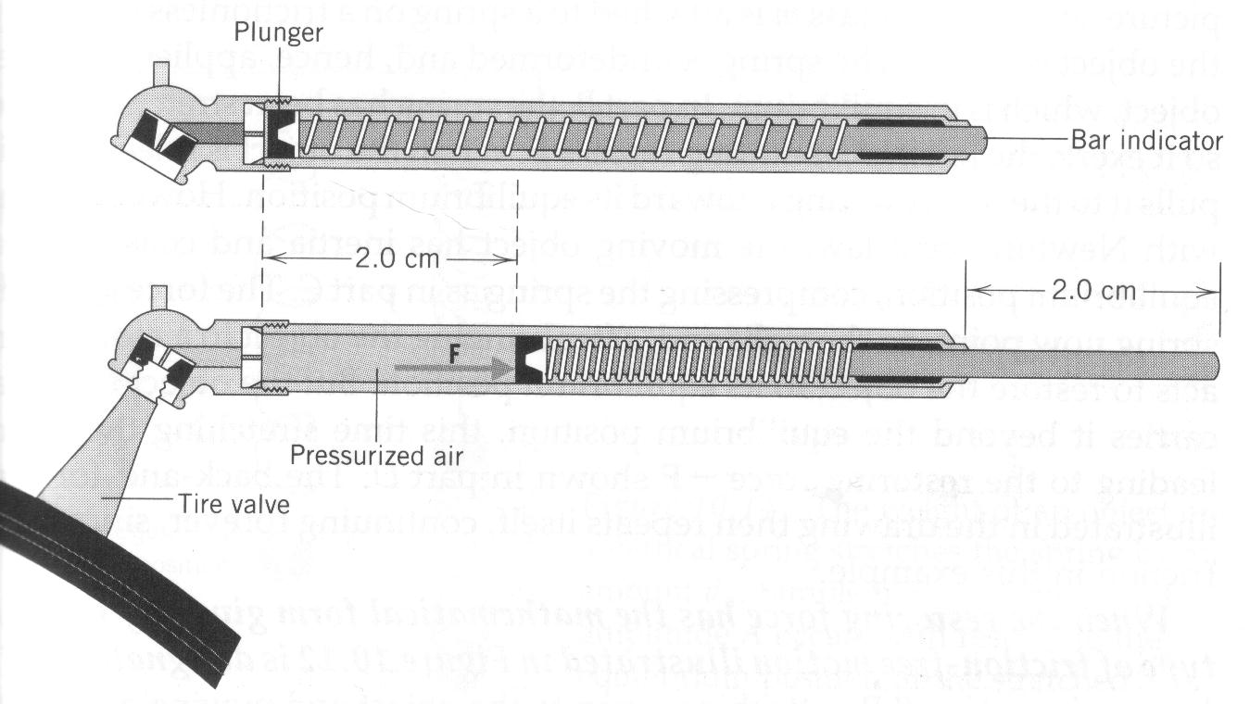
The force (F_{s}) required to stretch or compress a spring is directly related to the stiffness of the spring (represented by the spring constant k) and the amount that the spring is stretched or compressed (x). The force supplied by a spring, elastic band, bungee cord, etc. can be calculated using a simple relation called Hooke’s law (named after the efforts of Robert Hooke (1635 - 1662)).
F_{s} = –k x
Where:
F_{S} - spring force (N)
k - spring constant (kg/s²) or (N/m)
x - amount of compression or extension of the spring from equilibrium point (m)
Note: the negative sign is there to remind us that the spring force is always a restoring force to the equilibrium point.

The spring constant (k) is a number that tells us how stiff or powerful a spring is. For example, the compression spring in the suspension of a car has a very high spring constant since the spring requires a lot of force to compress. For a spring in a ball point pen, the spring constant is quite small.

In a tire pressure gauge, the air in the tire pushes against a spring when the gauge is attached to the tire valve as in the figure above. If the spring constant is 320 N/m and the bar indicator extends 2.0 cm, what force does the air in the tire apply to the spring?

F = k x = 320 N/m (0.020 m) = 6.4 N

When a 2.45 kg mass is vertically hung from a spring, the spring stretches by 12.4 cm. What is the spring constant of the spring?
F_{g}
F_{s}
0.124 m
2.45 kg

F_{s} = F_{g} = 2.45(9.81 m/s²) = 24.03 N

= 194 N/m

•

Vibrating weighted springs – period of vibration
The equation for the period of a vibrating spring is:

(ideal spring equation)
T - period (s)
m - mass of the weight (kg)
k - spring constant (N/m)

For an ideal spring, the spring is considered to have a mass of zero (m_{S} = 0). Notice that the period of vibration does not depend on the acceleration of gravity or on the amplitude of vibration.

What is the period of a vibrating spring (spring constant = 100 N/m) if a mass of 500 g is hung from the spring?

Practice problems
1. A 500 g mass is vertically hung from a spring. If the spring stretches by 22.75 cm, what is the spring constant? (21.56 N/m)
2. An ideal spring requires 16.5 s to vibrate 25 times when a 200 g mass is attached to the spring. What is the spring constant? Does it matter if the spring vibrates horizontally or vertically? (18.1 N/m, no)

Hand-in assignment
1. If a 500 g mass causes a vertical spring to stretch 79 cm, what is the spring constant? (6.2 N/m)

2. Five people with a combined mass of 275.0 kg get into a car. The car's four springs are each compressed a distance of 5.00 cm. Assuming the weight is distributed evenly to each spring, determine the spring constant of the springs. (1.35 x 10⁴ N/m)

3. What mass must be attached to a vertical spring with a spring constant of 85 N/m in order to cause it to stretch by 95 cm? (8.2 kg)

4. Two springs are hooked together and one end is attached to a ceiling. Spring A has a spring constant of 25 N/m, and spring B has a spring constant of 60 N/m. A mass weighing 40.0 N is attached to the free end of the spring system to pull it downward from the ceiling. What is the total displacement of the mass? (–2.3 m)

5. Explain the effect that changing each of the following factors has on the period of a mass-spring system:
(a) amplitude
(b) spring constant
(c) mass

6. A 4.5 kg mass is hung from a spring. If the force constant on the spring is 45 N/m,
A. What is the period of vibration for the spring? (2.0 s)
B. How long will it take for the spring to vibrate 150 times? (298 s)

7. A 1650 g mass is hung from a spring. If the spring vibrates 300 times in 8 minutes, what is the force constant of the spring? (25.4 N/m)

8. When a 5.75 kg mass is hung from a spring it stretches by 95 cm. If the spring is then set into vibration, how long will it take the system to vibrate 500 times? (977 s)

Activity 1 Hooke’s Law
Objective:
To determine the value of the force constant (k) of a spring using Hooke’s Law.

Theory:
Hooke’s law is given by the equation F_{s} = k x. Rearranging the equation we get:
Thus, if we measure the amount of stretch (x) for different hanging weights (F_{s}), the slope of the line-of-best-fit will be the spring constant (k).
Procedure:
1. Using the materials provided and a table like the one below, hang a mass from a spring and measure the amount that the spring stretched. Ask the instructor about which masses to use.
2. Plot a graph, draw a line of best fit and calculate the spring constant.
3. Draw a free-body diagram of the forces acting on the mass.

Mass (kg) | calculated F_{s} (N) | x (m)
0.20

0.40

0.60

0.80

1.00

Write-up
- Neatly organised data table of measurements and observations.
- Neatly plotted graph and calculation of the slope.
- Free-body diagram.

Activity 2 Vibrating spring equation
Objective:
The objective is to determine the value of the force constant (k) of a spring using the ideal spring equation.
Theory:
The ideal vibrating spring equation assumes that the spring is massless. This is often a good assumption if the mass is considerably larger than the mass of the spring (m >> m_{s}) . The ideal vibrating spring equation is:

The real vibrating spring equation is:
where m_{s} is the mass of the spring

Procedure:
1. Using the materials provided and a table like the one below, measure the period of vibration for at least four different masses hanging on the spring and calculate the value of the spring constant for each trial.
2. Calculate the average value for the spring constant.
3. Compare the result for the spring constant found in this activity with the result from the Hooke’s Law activity.

Mass (kg) | time for 10 full vibrations (s) | T (s) | k (N/m)
0.40

0.60

0.80

1.00

Write-up
- Neatly organised data table of measurements and observations.
- Sample calculation of k value and calculation of average.
- Comparison of results.

